Lecture 1.1.5: Principles of Inclusion & Exclusion
Course outcome to be covered:
CO1: Apply and recognized about the theory of sets.

Cartesian product, Principles of Inclusion & Exclusion
Principles of Inclusion & Exclusion:
The principle of inclusion and exclusion (PIE) is a counting technique that computes the number of elements that satisfy at least one of several properties while guaranteeing that elements satisfying more than one property are not counted twice.
An underlying idea behind PIE is that summing the number of elements that satisfy at least one of two categories and subtracting the overlap prevents double counting. For instance, the number of people that have at least one cat or at least one dog can be found by taking the number of people who own a cat, adding the number of people that have a dog, then subtracting the number of people who have both.
PIE is particularly useful in combinatorics and probability problem solving when it is necessary to devise a counting method that ensures an object is not counted twice.
If the two sets are disjoint then ∣A∪B∣=∣A∣+∣B∣.
In the case of objects being separated into two sets, the principle of inclusion and exclusion states.
∣A∪B∣=∣A∣+∣B∣−∣A∩B∣
where |S|, ∣S∣ denotes the cardinality or number of elements, of set S in set notation.
Note that the sets A and B might have some common elements. To be specific, the number of common elements between A and B is ∣A∩B∣. Each of these elements is counted twice in |A| + |B| (once in |A| and once in |B|), although it should be counted as one element in |A∪B|. Therefore, the double count of these elements in |A| + |B| should be adjusted by the subtraction of the term ∣A∩B∣ in the right-hand side of the above equation.
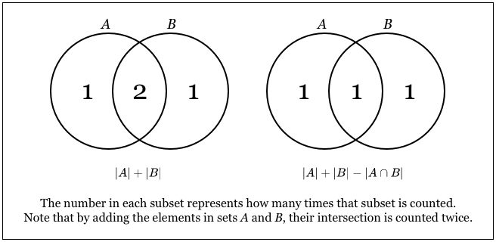

Example:
How many integers from 1 to 100 are multiples of 2 or 3?
Let A be the set of integers from 1 to 100 that are multiples of 2, then |A| = 50.
Let B be the set of integers from 1 to 100 that are multiples of 3, then ∣B∣=33.
Now, A∩B is the set of integers from 1 to 100 that are multiples of both 2 and 3, and hence are multiples of 6, implying ∣A∩B∣=16.
Hence, by PIE,
∣A∪B∣=∣A∣+∣B∣−∣A∩B∣=50+33−16=67.
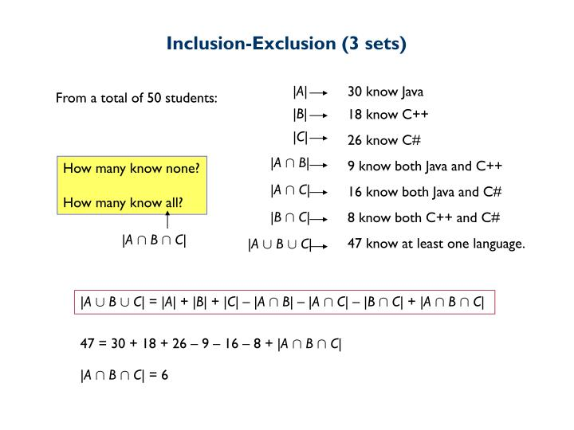
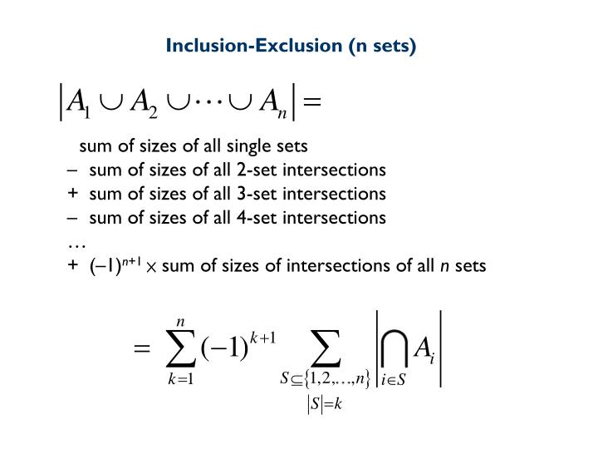
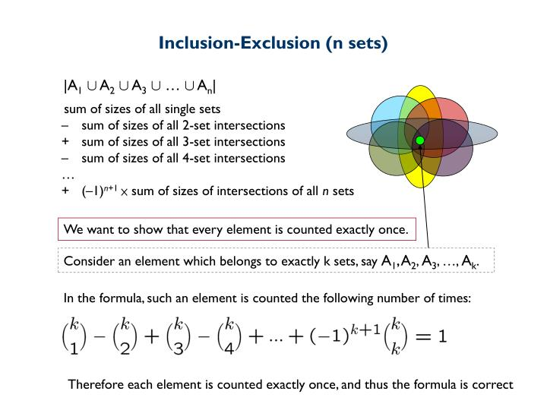
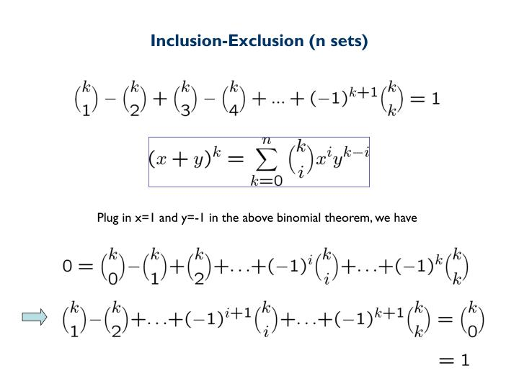
Applications
Counting problems:
Consider the problem. How many positive integers less than 100 is not a factor of 2,3 and 5?
For solving this problem at first we have to find the number of positive integers less than 100 which are divisible by 2 or 3 or 5.
Let A = The set of elements which are divisible by 2, B = The set of elements which are divisible by 3, and C = The set of elements which are divisible by 5.
By principle of inclusion and exclusion :
|A ∪ B ∪ C| = |A| + |B| − |A ∩ B| − |B ∩ C| − |A ∩ C| + |A ∩ B∩ C|
= [99/2] + [99/3] + [99/5] − [99/2 ∗ 3c] − [99/3 ∗ 5] − [99/2 ∗ 5] + [99/2 ∗ 3 ∗ 5]
= 49+33+19-16-6-9+3 = 73
So the total number of integers which are not a factor of 2 or 3 or 5 is 99 − 73 = 26
Derangements Problem Statement:
A derangement is a permutation of the elements of 1, 2, 3, · · · n such that none of the elements appear in their original position. Principle of inclusion and exclusion can be used to count number of such derangements among all possible permutations.
Solution:
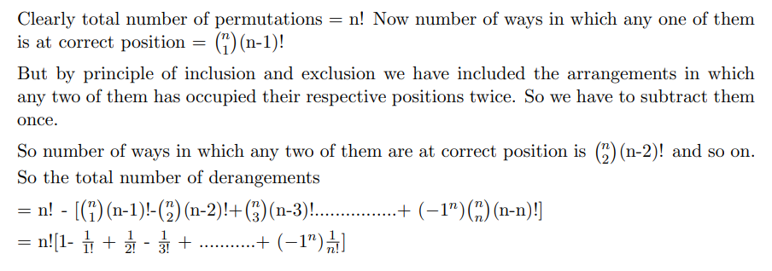
ebook Discrete Mathematics
https://vcarrion.people.uic.edu/Pinter%20-%20A%20Book%20of%20Set%20Theory.pdf
LINKS: https://youtu.be/MassxXy8iko

